Setting up Application Environment

Create Sendgrid Account

|  |  |
| --- | --- |
| Date | 1 Nov 2022 |
| Team ID | PNT2022TMID07494 |
| Project Name | Skill/Job Recommender Application |

Step 1. Navigate to https://sendgrid.com

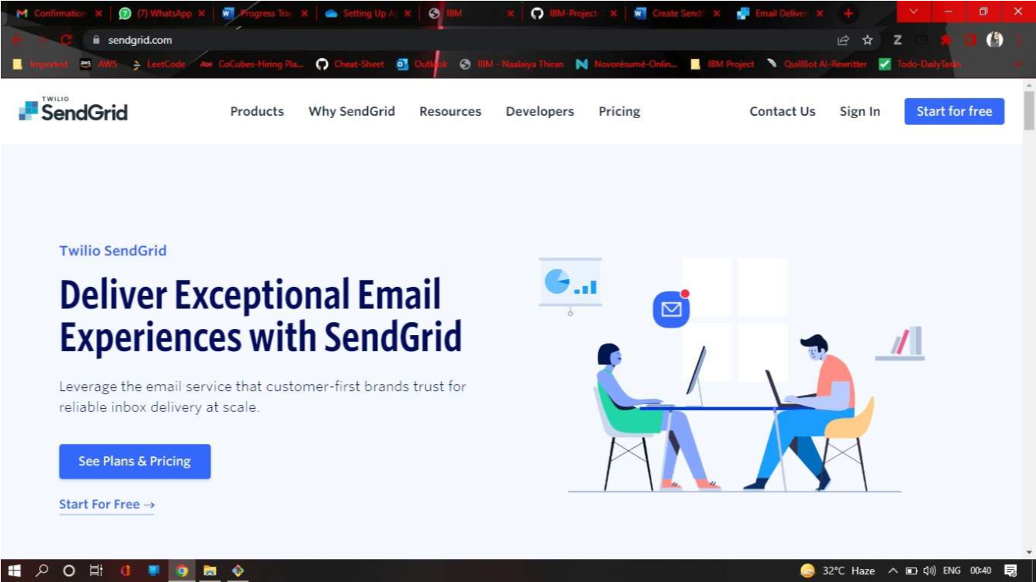

Step 2. Click on “Start for free” and register yourselves by entering required details and click on create account 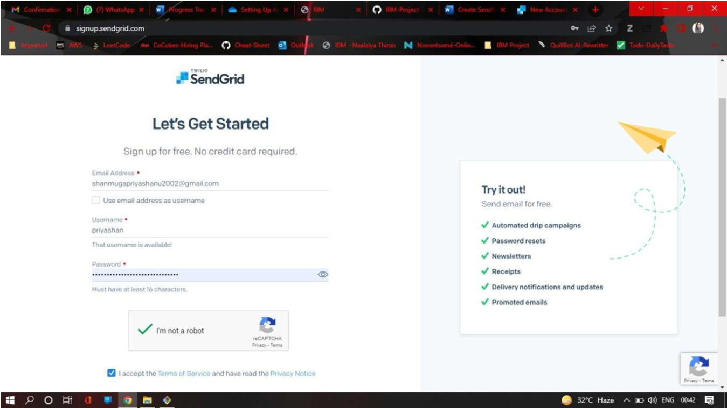

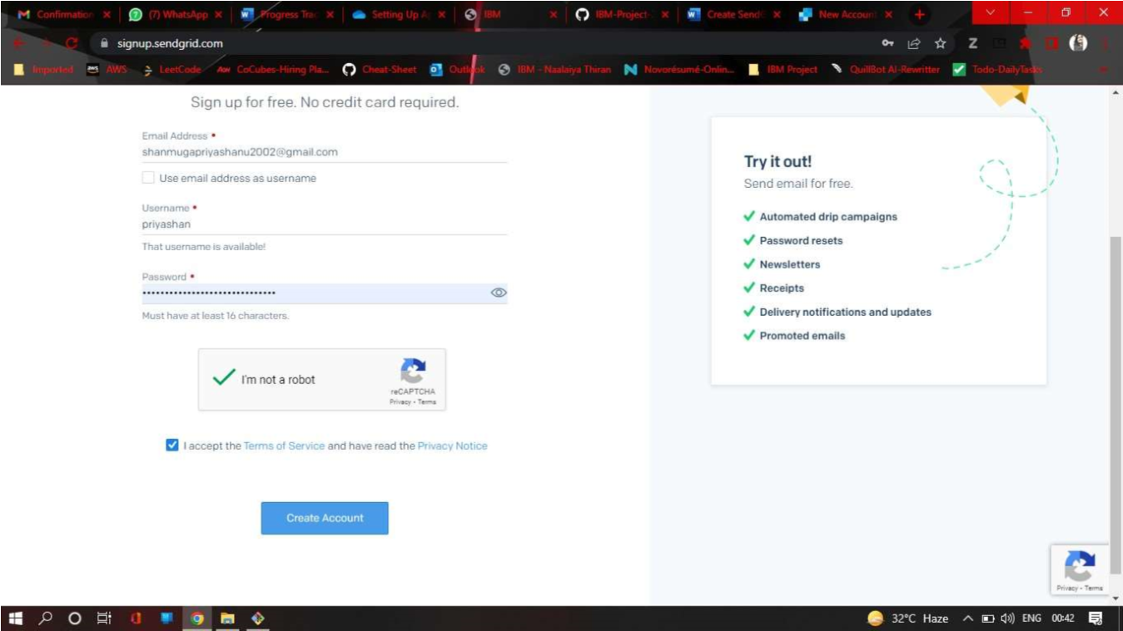

Step 3. Further fill all required details in next page and click on get started as shown below

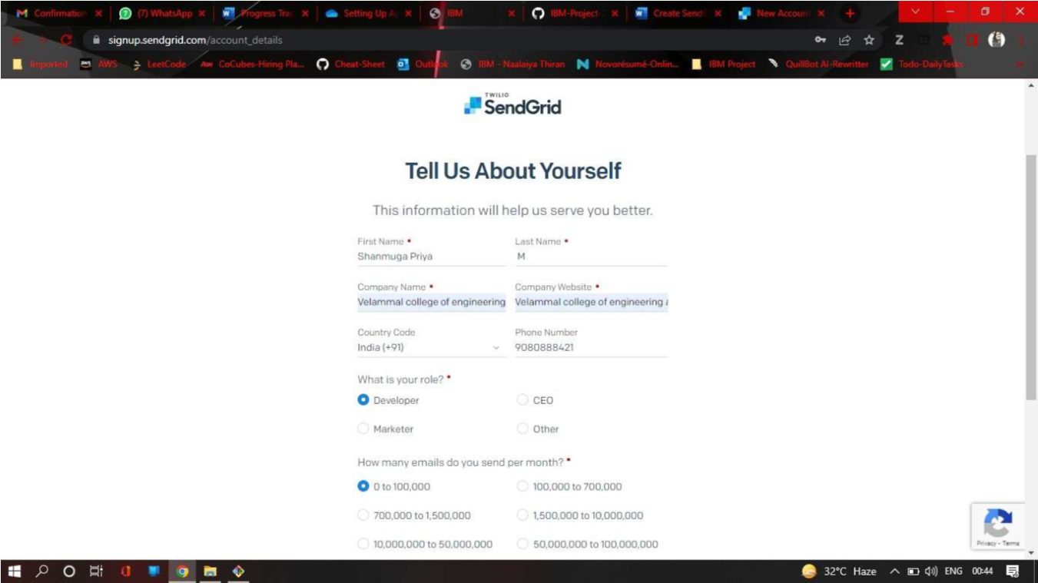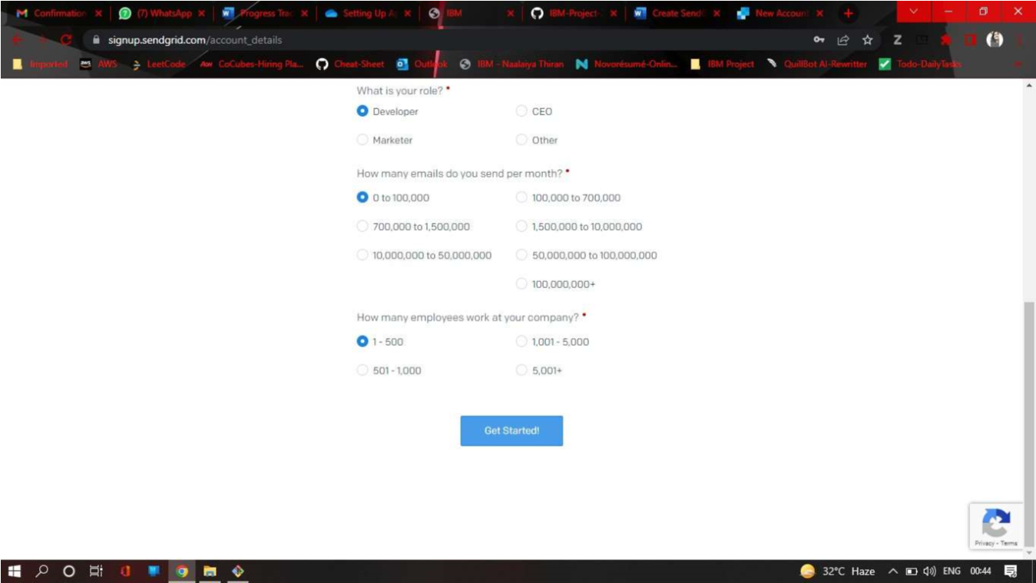

Step 4. That’s it you have created your SendGrid account and got access to dashboard

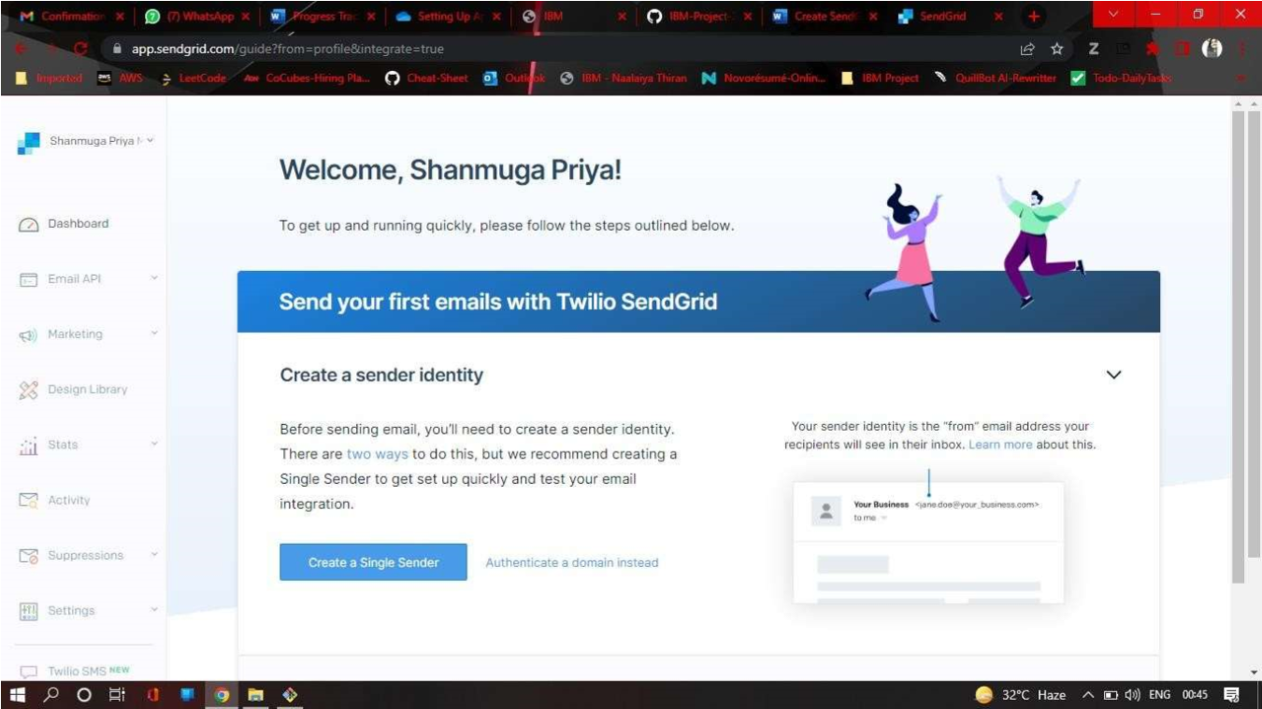

Output:

Send Grid account created successfully.